Name___________________________ input.doc

1) Given the function f(x) below indicate if f(x), f’(x), and f’’(x) are positive, negative or zero at each point.
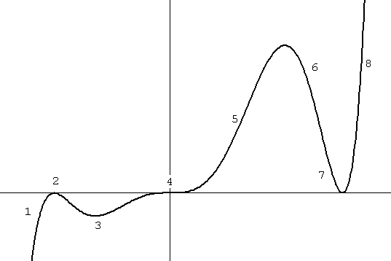
Point | f(x) | f’(x) | f’’(x)
1
2
3
4
5
6
7
8

2) Mr. Haas eats his “Math Cereal” each morning and notices that there is a relationship between the temperature of the milk he puts on the cereal and the time for the cereal to get soggy. The time to get soggy (in minutes) is a function of the milk temperature (in Degrees Celsius).

Explain the meaning of the following.
(Include Units!!!)

a) f(4)=5

b) f’(4)=-0.5

c) Mr. Haas finds that warmer milk temperatures make the cereal soggier faster. However, the amount of time it takes to get soggy decreases at a slower rate as the milk gets warmer.
(That is - an increase in milk temperature has a greater effect on the time to get soggy at lower temperatures than at higher temperatures.)

Sketch a graph of this relationship.

What must be true about the sign of f’’(x)?
3) The acceleration of a Ferrari F430 is tested on a track.

Time  (seconds) | Total Distance  (feet)
0.0 | 0
1.0 | 12
2.0 | 48
3.0 | 108

The total distance (in feet) traveled by the Ferrari was recorded each second for a 3 second interval.

a) Make a rough sketch (do NOT plot the exact points) of time vs. distance, velocity, and acceleration graphs below. You MUST label the axis.
time(seconds)
Distance
(feet)
time(seconds)
Velocity
(feet/sec)
time(seconds)
Acceleration
(feet/sec²)

b) Determine the acceleration of the car as a function of time.

4) For equally high quality diamonds the cost (in thousands of dollars) is a function of weight (in carats). c=f(w).

a) A 2 carat costs $6,000 is best expressed as:

(1) f(6)=2 (2) f(2)=6 (3) f’(2)=6 (4) f’(6)=2

b) Since large diamonds are more rare, the larger a diamond is the greater the cost per carat. Which of the following must be true?

(1) f’(x)>0 (2) f’(x)<0 (3) f’(x)=0


(4) f’’(x)>0 (5) f’’(x)<0 (6) f’’(x)=0

5) Sketch the first derivatives of the functions below.
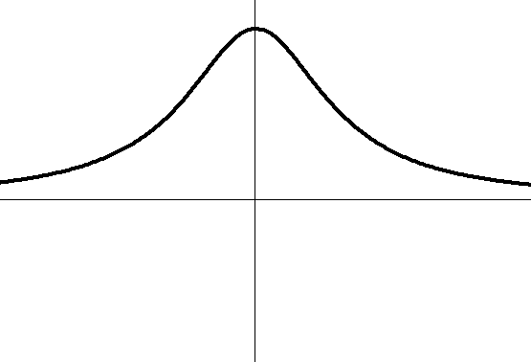
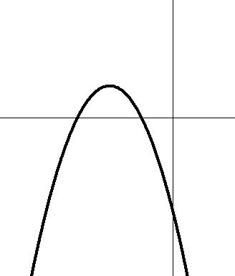
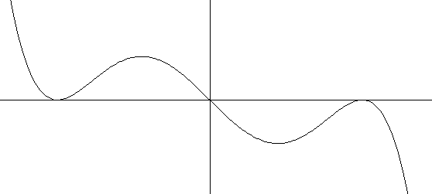

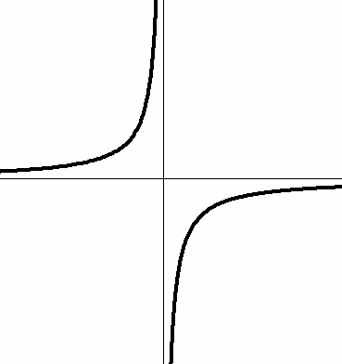
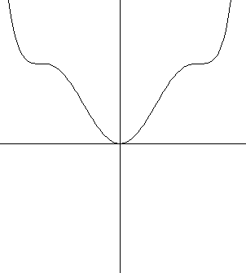
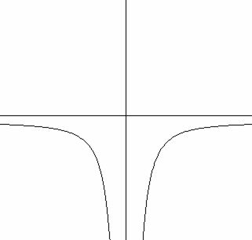
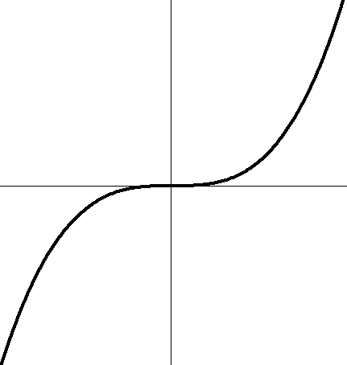

6) Sketch a function given the following information about its first and second derivative.

f’(x) < 0 for all x in the domain f’(x) > 0 for x < 0
f’’(x) > 0 for x < 0 f’(x) < 0 for x > 0
f’’(x) < 0 for x > 0 f’’(x) < 0 for all x in the domain

